Title of my booklet
___________________________________________________________________________
Write or draw the answers to these questions about your story.
Who is in it?
Where does it take place?
What happens?

Describe the main character.
The main character’s name is __________________________________________________.
He / she lives _______________________________________________________________.
He / she is __________________________________________________________________.
He / she loves _______________________________________________________________ .
He / she doesn’t like __________________________________________________________.
What do you like about the story?

___________________________________________________________________________

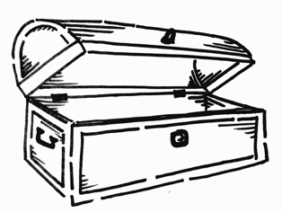
My treasure of new words
Collect useful new words from the story.

The word in English | What it means | A picture or symbol of the word

