zebra finch 4 by Jim Bendon is licensed under CC BY-SA 2.0.
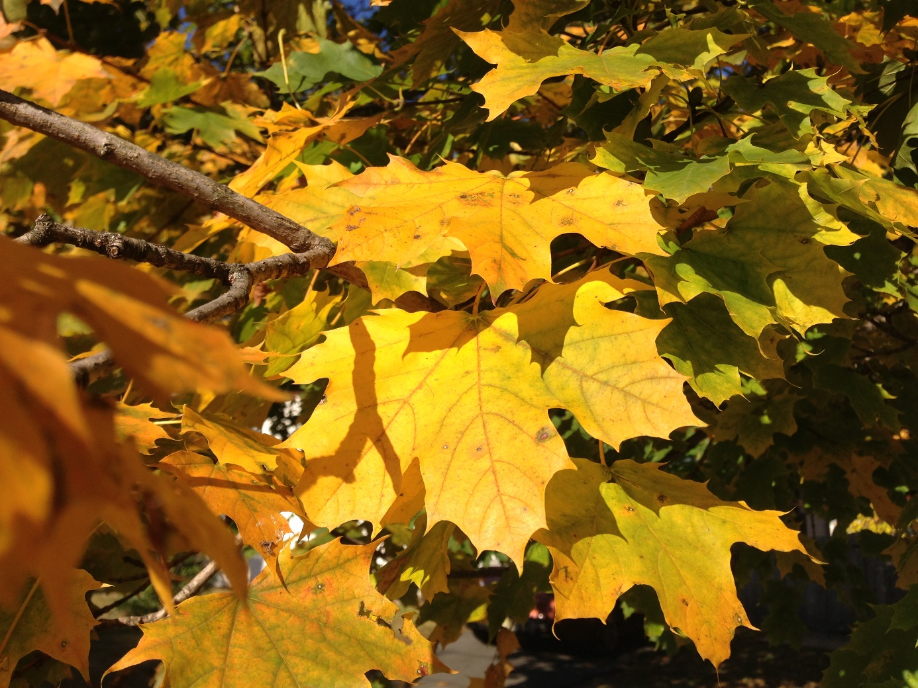
"File:2014-10-30 10 39 54 Norway Maple foliage during autumn on Durham Avenue in Ewing, New Jersey.JPG" by Famartin is licensed under CC BY-SA 4.0.
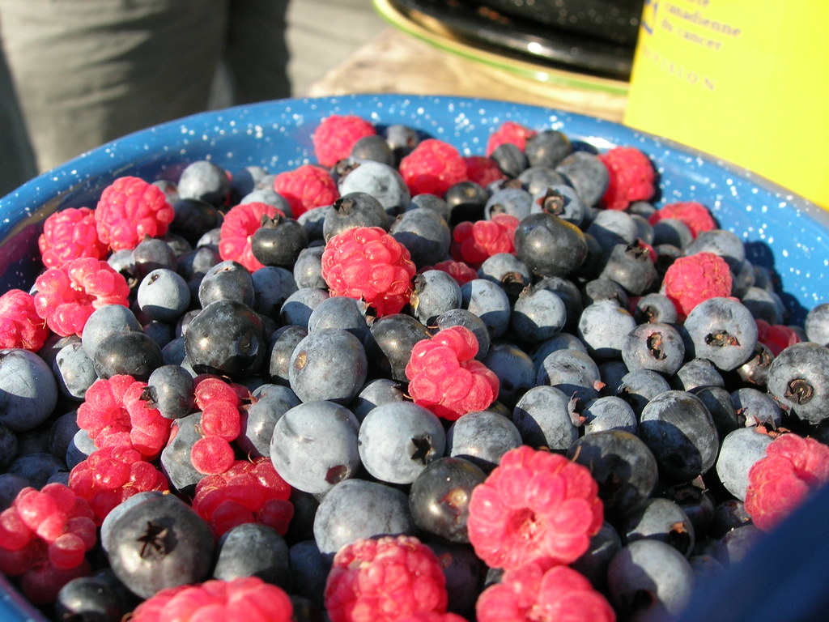
"Berries" by Dano is licensed under CC BY 2.0.
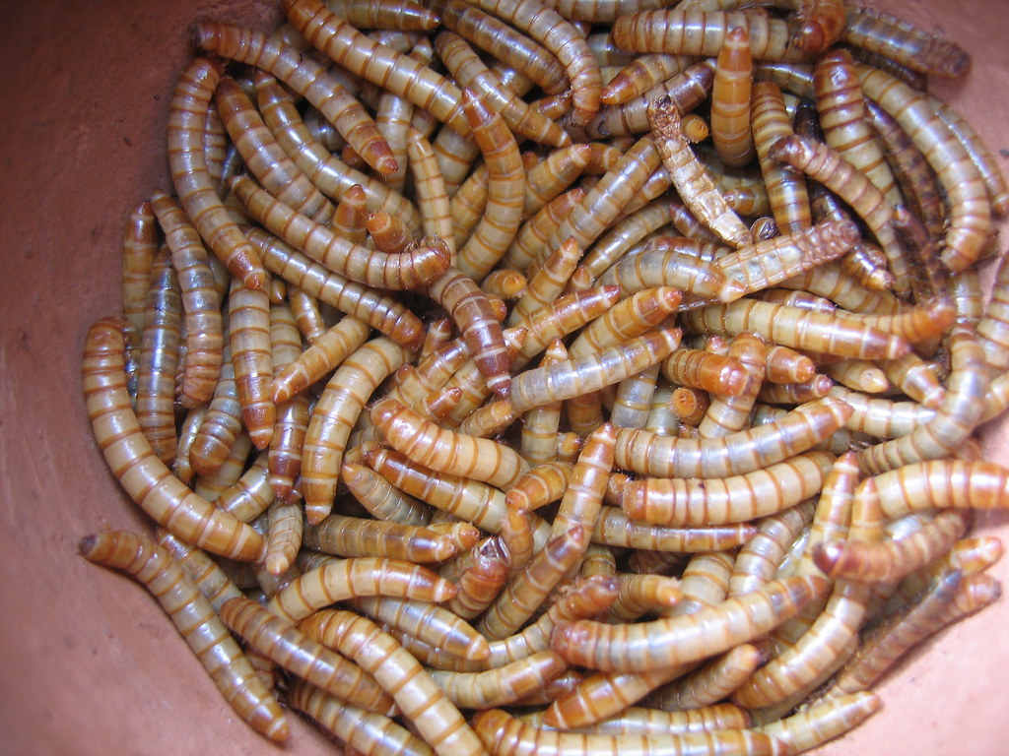
"mealworms" by hans s is licensed under CC BY-ND 2.0.

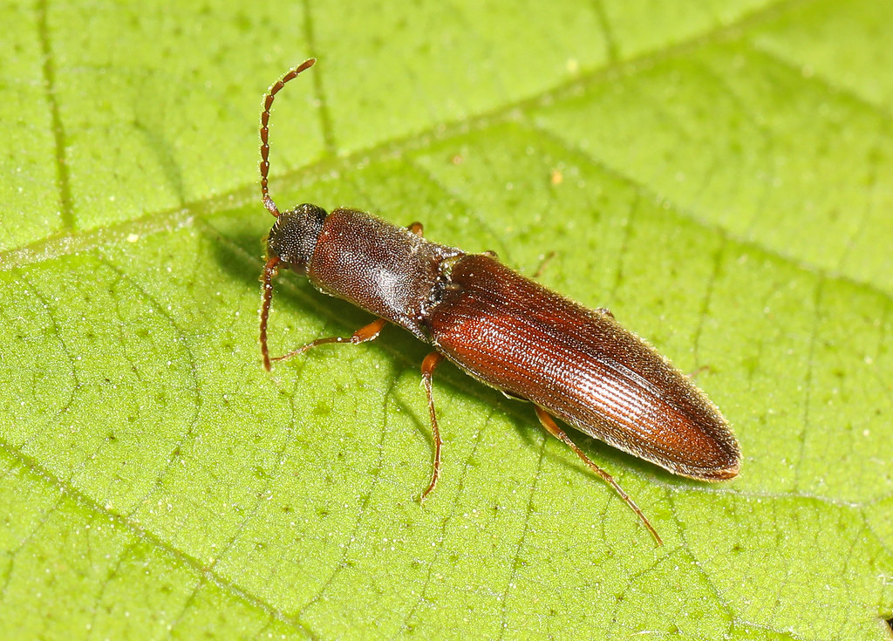
"Click Beetle - Agriotes oblongicollis, G. R. Thompson Wildlife Management Area, Linden, Virginiia" by Judy Gallagher is licensed under CC BY 2.0.

