Under water bath salt animals
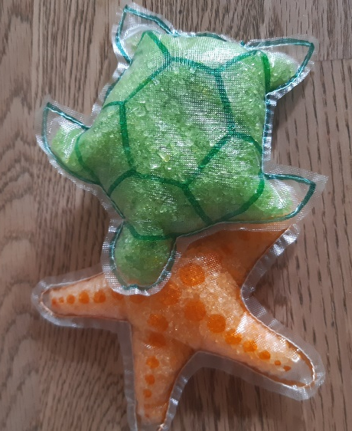
Tools and materials
- sewing machine
- Wash-away sewing fleece (Madeira Avalon)
- Wash-away thread (Madeira)
- Sea salt
- Food colouring
- Scented oil
- Waterproof felt tip
- scissors
- under water animal templates
- zipper foot
___________________________________________________________________
Instructions
- Choose an animal template and cut the wash-away fleece doubled in size.
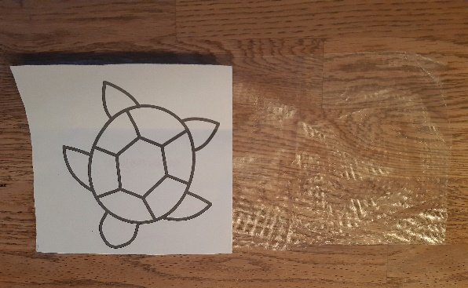
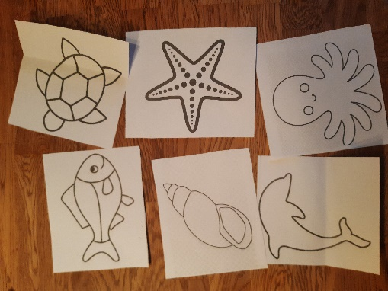

- Put the template under the fleece and draw the outlines of the animal with the waterproof felt tip on the fleece.
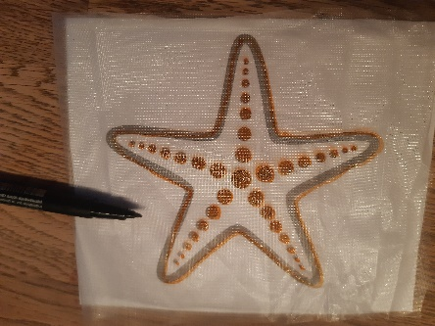
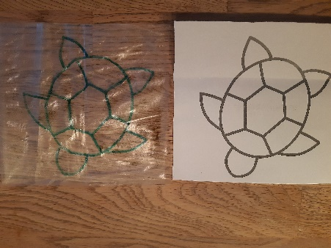
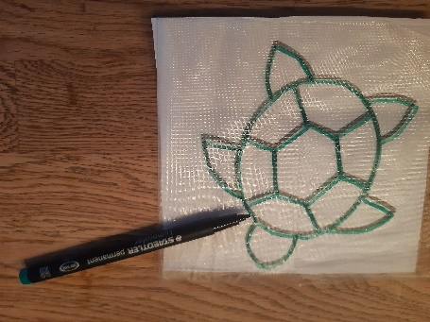

- Lay the fleece doubled and pin it together.
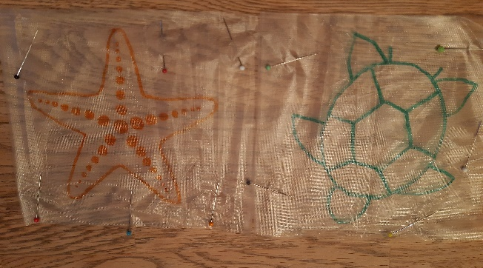

- Sew along the line with the wash-away threat, leave an opening.
- Straight stitch: stitch length 3
- At the beginning and at the end sew forwards and backwards.
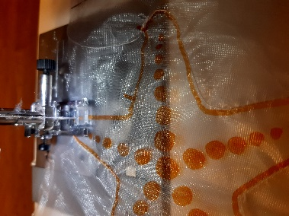

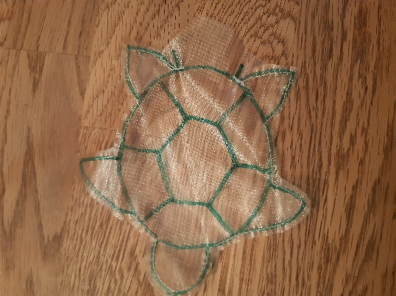
- cut out the animals, cut about 3 mm along the sewing line. Leave more fleece around the opening.
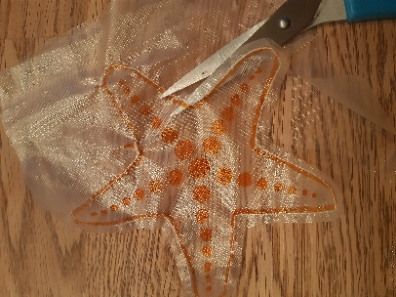

- Mix the sea salt with some drops of food colouring, then mix about 20 drops of scented oil under the salt.

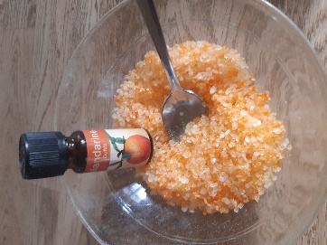
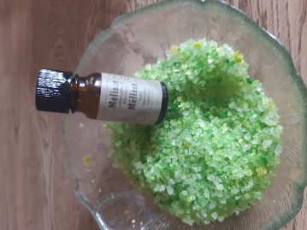

- Make a funnel with a piece of paper and fill the salt mixture in the animals.
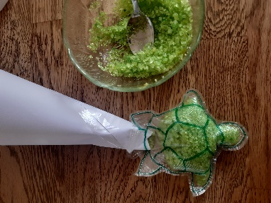
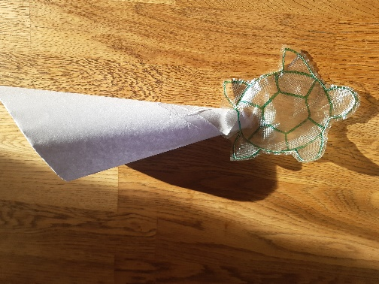

- Attach the zipper foot, needle position far left, and sew the opening close. At the beginning and at the end sew forwards and backwards.
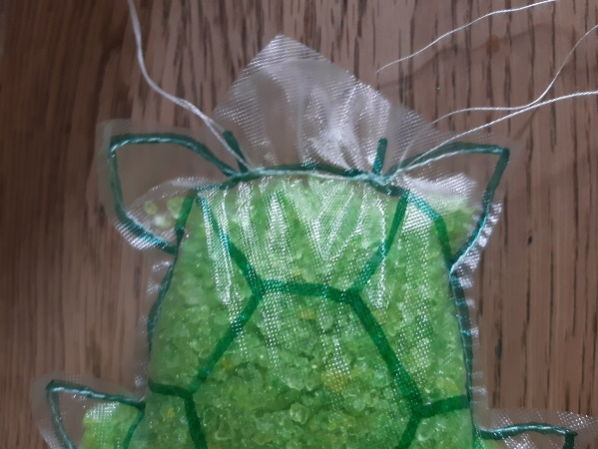
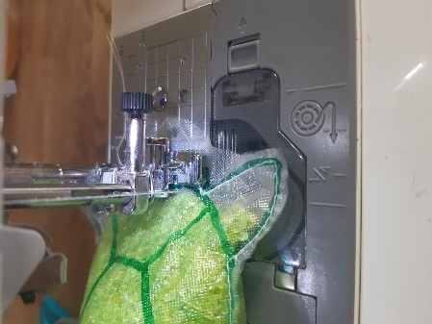

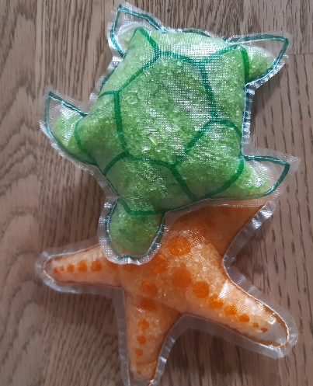
- Cut away the left-over fleece at the opening.

