TASK FRAME

|  |  |  |
| --- | --- | --- |
| **YOUNG WORLD**  **UNIT & TOPIC**  Young World 2  Unit 5, Are we there yet? | **TASK**  **Let’s have a**  **toy car race!**  Pupils bring a toy car and introduce it to class (I travel by a yellow race car.). The cars compete against each other in different runs. After each race they evaluate what has happened and write it down. In the end the winner of each group reaches the final. | **REFERENCE TO LP21**  - Grammatik  - Aussprache  - Wortschatz  - Sprechen: Strategien  - Soziale Kompetenzen |
| **PRE-TASK**  Pupils compare different means of transport:  …is faster than…  …is slower than…  …is the fastest.  …is the slowest. | **LANGUAGE SUPPORT**  Repetition of ranking words:  first, second, third…  ☞ on the ranking list |
| **TASK INSTRUCTION**  Work in groups of four or five. Introduce your toy cars to class. Use the ranking list given. Make a toy car race outside. Mark START and FINISH. After the race you fill in the ranking list and present it to class. The winner of each group reaches the final. Evaluate the final too. | **TASK OUTCOME**  Comparison of different toy cars on front of the class. | **PRESENTATION FORM**  Oral presentation of the ranking list in groups of four or five. |
| **LANGUAGE FOCUS**  -faster / slower than  -ranking words | **ESTIMATED TIME**  To have the races and the presentation: 1 lesson | **MATERIALS NEEDED**  - toy cars  - chalk  - ranking list |

AUTHOR: Heidi Troxler-Näf

|  |  |  |
| --- | --- | --- |
| MCj04046570000[1] | **Are we there yet?** YW 2 Unit 5 | **4. Kl.** |
| … is faster than … / … is slower than … Research Project |

**Racing duel: On your mark. Get set. Go!**

|  |  |  |  |  |  |
| --- | --- | --- | --- | --- | --- |
|  |  |  | 1st race | 2nd race | 3rd race |
| (1.) | **1st** | **first** |  |  |  |
| (2.) | **2nd** | **second** |  |  |  |
| (3.) | **3rd** | **third** |  |  |  |
| (4.) | **4th** | **fourth** |  |  |  |

What was faster than … ? What was slower than … ?

What was the fastest? What was the slowest ?

**Write three sentences about the race!**

_____________________________________________________________________

_____________________________________________________________________

_____________________________________________________________________

_____________________________________________________________________

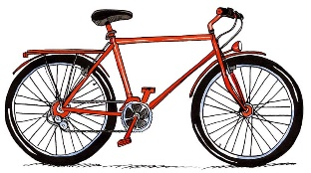 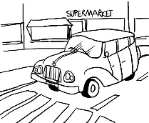

A bike is slower than a car. A car is faster than a bike.

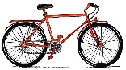 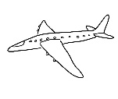

A bike ______________________________________________________ a plane.

A plane ______________________________________________________ a bike.

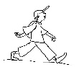 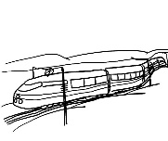

A train _____________________________________________________________

A hiker _____________________________________________________________