TASK FRAME

YOUNG WORLD  UNIT & TOPIC  YW 3, Unit 5  Food and festivals | TASK  Funny game with questions and matching or non-matching answers.  Write questions and short answers with the given question words.  Write the question on a yellow paper strip  Write the answer on a green paper strip  Play with these cards: Take one strip from every colour. Do they match? Some answers may be funny! | REFERENCE TO LP21  Reading  Understanding  Spelling  Range of vocabulary
PRE-TASK  Questions words  How to form a question? |  | LANGUAGE SUPPORT  Question words  Questions form  What do you…  Where do you ….  How do you…..  on the blackboard
TASK INSTRUCTION  Work in groups of 3 or 4  Write questions and answers on a strip of paper  Let them check by the teacher  Write them down on yellow and green strips of paper | TASK OUTCOME  Groups play the game in different forms:  Memory: Find the matching strips.  Mix the strips and make matching pairs.  Take one from each pile: Do they match? | PRESENTATION FORM  Questions and answers on coloured strips of paper
LANGUAGE FOCUS  Question form: do you…..  Question words:  what, where, how, who, when, why, … | ESTIMATED TIME  20’ to write questions and answers  10’ to write the questions and answers on coloured strips  Time to play the game: Several times over the next few weeks. | MATERIALS NEEDED  Yellow and green strips of paper
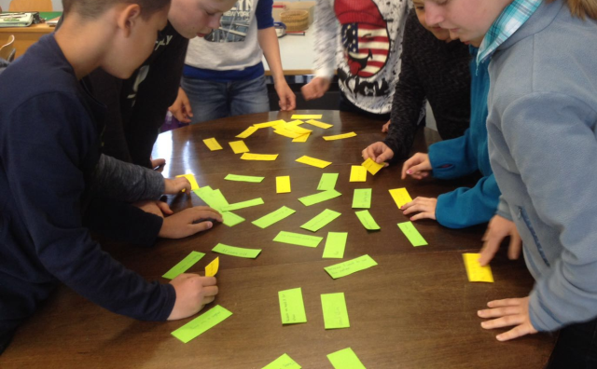
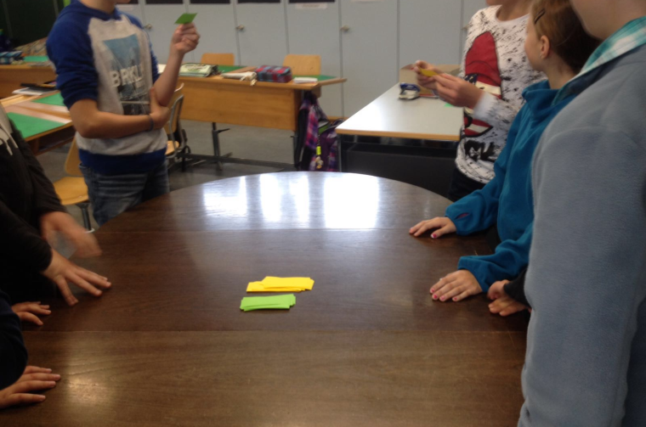
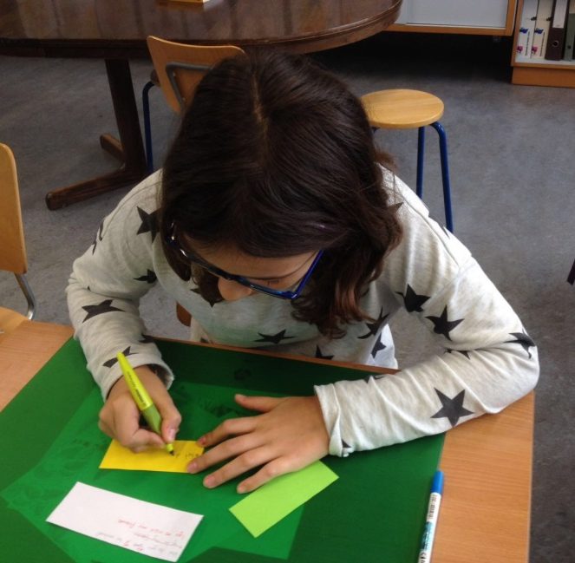
AUTHOR: Käthi Estermann

