TASK FRAME

YOUNG WORLD  UNIT & TOPIC  YW3, Unit 7  Sports and games  Create (and plan) a sport day at your school | TASK  Create your own sports day  Carry out a planning of a sports event at your school in a group of three.  Consider in your planning the infrastructure given, possible weather condition.  Plan half a day of a sports event with timetables, schedule class or groups playing and introduce a new sport (football, baseball, cricket: material will be at your disposal).  Present your poster (A0). Each member should have equal speech time. Time for presentation: max. 10 min. | REFERENCE TO LP21  –Monologisches u. Dialogi-  sches Sprechen (sprachli-  che Mittlung)  –Sprechen: Strategien  –Wortschatz und Aussprache  –Grammatik  - Kulturen im Fokus ( Kennt-  nisse)  - Ästhetische Wirkung  –Soziale Kompetenzen
PRE-TASK  -listen to sports event, find  out which sport is involved  -play different sports and let  the pupils explain all details!  -Which sport types do you  already know  -Can you explain them  (rules, how to play, details)  -which sport would you like  to know in this unit  -What do we need to know  in order to plan a sports day  (weather, map)  -Where do we get the neces-  sary informations |  | LANGUAGE SUPPORT  -Vocabulary list (sep.)  -verbs (picture and word),  resource book Explorers  -AB/PB YW3, Unit7  -“Past”-Dossiers (sep.)  -phrase-examples (questions to start the lessons or end the lessons) such as:  My favourite sport is, I know to play…, the rules are…  we can explain, show, teach….there will be…
TASK INSTRUCTION  -Groups of 3: plan to orga-  nise a sportsday including  mapping, timing/scheduling,  planning  - create a timetable of the  sport events (groups)  -prepare to present a new  sport (football, baseball,  cricket) to your colleagues. | TASK OUTCOME  -poster presentation  -in June: carry out thesports- day (5th graders)  -write a feedback of at least  10 sentences about the  planning of your sportsday  in the past form. | PRESENTATION FORM  -poster presentation (A1)
LANGUAGE FOCUS  -vocabulary sport, weather,  activity verbs  -be able to give instruction  -use present and past verb  forms (regular and irregular  forms)  -be able to use the ordinal  numbers | ESTIMATED TIME  -3 lessons: preparation of the poster inclusive presentation | MATERIALS NEEDED  -poster material  -pictures for poster  -sports material to introduce  a new sport (football, base-  ball, maybe cricket  -individual material for the  poster
EVALUATION:
-poster presentation evaluation by criterias (separate worksheet)
1st part: presentation itself (details), 2nd part: speaking
-ranking of the presentation by all pupils (the winner of the presentation is planned to be the
role model for carrying out the sports day/ under circumstances combinations of it.)
-prepare a 10 sentences feedback about the sports day presented (writing, use past)

AUTHORS: Monika Grüter, Schule Ruswil in Ziswil

Keep in mind when working with tasks:
-engage all learners
-primary focus an meaning
-is there an outcome (define)
-is success judged in terms of outcome
-is completion a priority
-relate to real world activity: (transfer: sports day in Ziswil, in June)

Additional material: Handout pupils task & Evaluation sheet

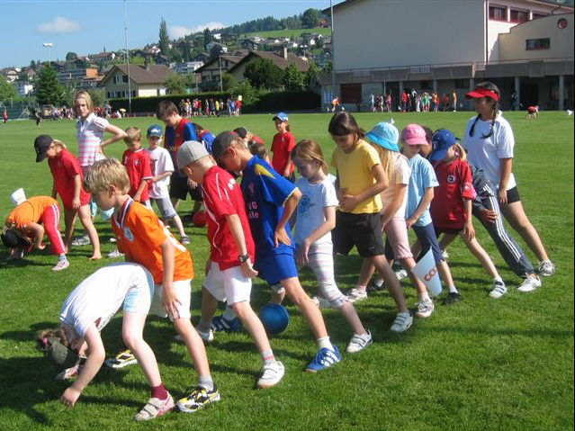
Sports day
Prepare in a poster-presentation
about a sports day at your school.

Presentation-Sheet:
- Facts that should be mentioned or taken in account: different sports, group games, places, materials, weather conditions, responsibilities
- Time setting: schedule the sport events (half a day)
- Present one new sport (rules, how to play, etc.)
- Structure your poster: f.e. with mind-mapping, clustering, bullets, charts, add pictures, fotos, drawings, etc.
- Present the poster to your colleagues (max. 10 min.)

Task goals:
- You will learn to organise and plan a sports day at your school (
- You will learn about new sports and how to play them
- You will teach about a new sport (football, baseball, cricket)

Oral evaluation
Class:________________

Name: | Date: | Productive skills
 |  | Formale Richtigkeit |  | Aussprache |  |  | Satzbildung |  | Inhaltlich (entspricht) | Wortschatz

Bewertung jeweils in halben Noten angeben: 6 - 1

